# **CS 1101-01: Programming Assignment Unit 3**

Godknows Egi

Bachelor of Science in Computer Science, Uopeople

CS 1101-01 - AY2024-T3: Conditionals and Recursion

Bianca Gilyot

February 20th , 2024

**Question 1**

The following is the countdown function copied from Section 5.8 of your textbook.

def countdown(n):

     if n <= 0:

        print('Blastoff!')

     else:

        print(n)

        countdown(n-1)

Write a new recursive function countup that expects a negative argument and counts “up” from that number. Output from running the function should look something like this:

>>> countup(-3)

-3

-2

-1

Blastoff!

Write a Python program that gets a number using keyboard input. (Remember to use input for Python 3 but raw_input for Python 2.) If the number is positive, the program should call countdown. If the number is negative, the program should call countup. Choose for yourself which function to call (countdown or countup) for input of zero.

Provide the following.

* The code of your program.
* Respective output for the following inputs: a positive number, a negative number, and zero.
* An explanation of your choice for what to call for input of zero.

**Question 2**

You are developing a program that performs a division operation on two numbers provided by the user. However, there is a situation where a runtime error can occur due to a division by zero. To help junior developers learn about error handling in expressions and conditions, you want to create a program deliberately containing this error and guide them in diagnosing and fixing it.

**Solution for Q1**

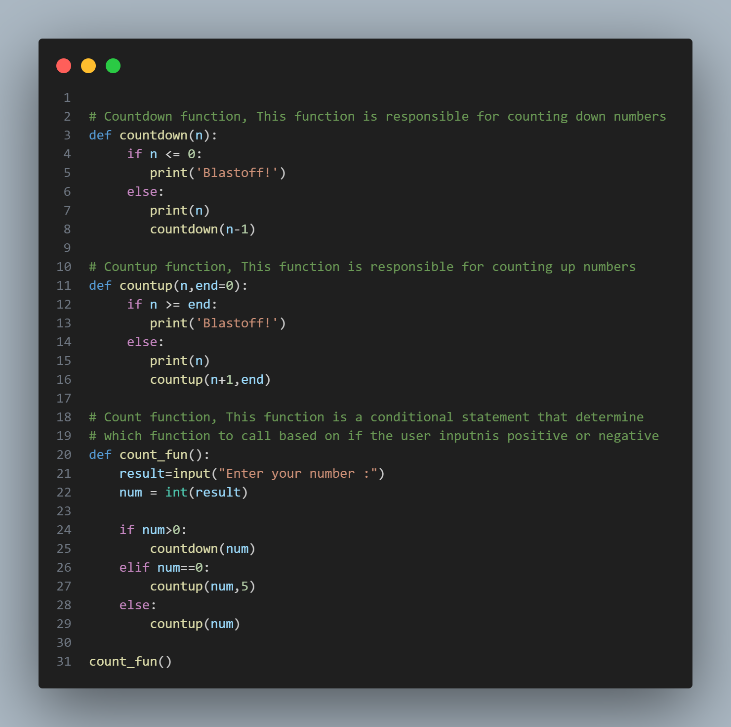

*Code for Q1, fig.1*

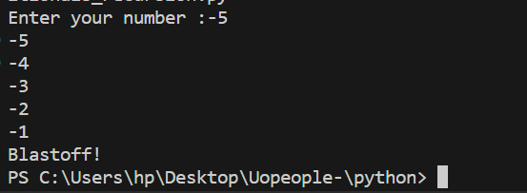

*Output for Q1: input value = -5, fig.2*

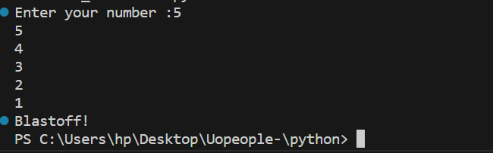

*Output for Q1: input value = 5, fig.3*

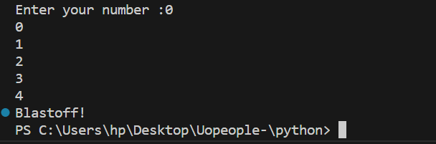

*Output for Q1: input value = 0, fig.4*

This is my final output for the first question. I created a function called **count_fun,** This function has a chained conditional statement that determines what function to call based on the user input i:e Positive or Negative numbers. It also accept inputs using the keyboard input function **input()** .

When a user input is zero I decided to call the count up function, But this will result to what will call an infinite recursion as referenced on Downey, A. (2015,). Think Python: How to think like a computer scientist, *Chapter 5.*  *Conditionals and Recursion (pp. 5.10)* since there no terminating condition for zeros, So I had to add an optional parameter called **end** with a default 0 incase no argument was provided for it, This end parameter serves as the termination number in the condition check for **countup function.** If the input is 0 then I add an end argument of 5 as shown on fig. 1 image.

**Solution for Q2**

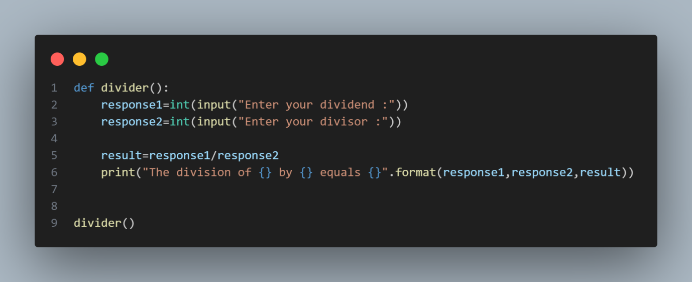

*Code for Question P2 fig.4*

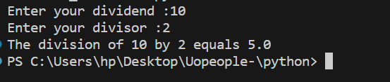

*Output for Q2 , 10/2=5*

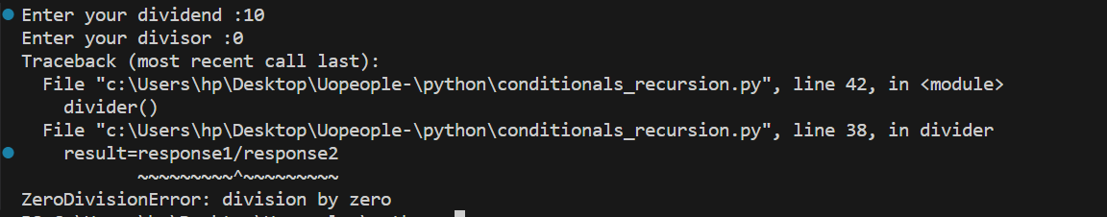

*Output for Q2 , 10/0*

I have created a function that performs a division operation on two numbers provided by the user, Now when a user inputs a dividend and a divisor value the function calculates and print the value, But in a scenario where the divisor is zero 0 it throws an error **ZeroDivisionError: division by zero** , Which means a divisor can’t be zero 0, to solve and handle this error we will have to put a check that handle this error gracefully without breaking our code, this check will lookout for when a divisor is zero 0 and print an error message telling the user that a divisor can’t be 0, Without breaking out code.

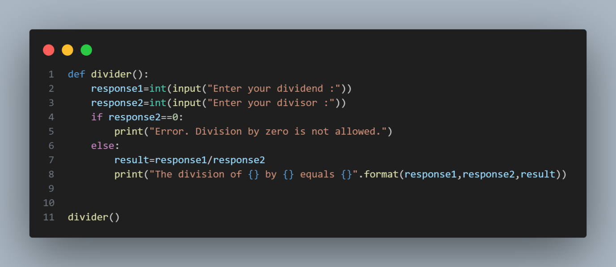

*Code for Question P2 : modified*

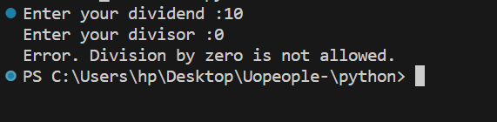

*Output for Question P2 : error handled*

**References**

Downey, A. (2015,). Think Python: How to think like a computer scientist ,*Chapter 5 - conditionals and recursion (pp 5.7)*

<https://greenteapress.com/thinkpython2/thinkpython2.pdf>